iOS M800 SDK
V1.0
Author: CUI XIAODONG
2021/05/14

Change Log
Date | Item | Person
2021-05-14 | File created | CUI XIAODONG
2022-10-28 | Add check WiFi signal method，firmware>1.37 | Xiaosan Liu
2023-11-15 | Add M800 function | Xiaosan Liu
2023-11-17 | invalid params | Xiaosan Liu

This Document is for Internal Use ONLY

Catalog

Change Log 1
Catalog 2
I. APP iOS SDK 5
Functions and Objectives 5
II. Integration 5
1 .Framework 5
2 . Integration 5
III. API Description 6
How to Call API 6
TCP Connect and Disconnect 7
Connect and login the TCP Interface 7
Parameter Description 7
Disconnect TCP Interface Automatically 7
TCP Disconnect Call Back Delegate 7
1. Turn on Real-time Data 8
Interface Description 8
Parameters Description 8
2. Stop Real Time Data 8
Interface Description 8
Parameters Description 8
3. Device Start to Collect (abandoned) 9
Interface Description 9
Parameters Description 9
4. Device Stop to Collect 9
Interface Description 9
Parameters Description 9
5.Get Collection Status 10
Interface Description 10
Parameters Description 10
6. Get Sleep Status 10
Interface Description 10
Parameters Description 10
7. Get Environment Parameters 11
Interface Description 11
Parameters Description 11
8.Firmware Upgrade Notification 11
Interface Description 11
Parameters Description 11
9.Query the Device WiFi Signal 12
Interface Description 12
Query the wifi signal of equipment 12
Parameters Description 12
10.Query the Device Online Status 12
Interface Description 12
Query the online status of equipment 12
Parameters Description 12
IV. Object Description 13
Notification 13
Description 13
Description 13
SLPBLEScanReturnCodes 13
Description 13
SLPDeviceTypes 14
Description 14
SLPTransforCallback 14
Description 14
Method Statement 14
Parameter Description 14
SLPDataTransferStatus 15
Description 15
SLPPeripheralInfo 15
Description 15
Fields Description 15
SLPDeviceInfo 15
Description 15
Fields Description 16
SLPEnvironmentInfo 16
Description 16
Fields Description 16
SLPCollectStatus 16
Description 16
Fields Description 16
SLPLTcpUpgradeInfo 17
Description 17
Fields Description 17
SLPSleepStatus 17
Description 17
Fields Description 17
SLPTCPPostRealtimeData 18
Description 18
Fields Description 18
SLPRealtimeDataBase 18
Description 18
Fields Description 19
SLPTCPOnlineStatus 19
Description 19
Fields Description 19
SLPTCPBaseEntity 19
Description 19
Fields Description 20

I. APP iOS SDK

Functions and Objectives
M800 SDK launched by Sleepace, is a software development kit for fast Internet APP development on iOS platform.

The SDK encapsulates the communication process between APP and hardware, and provides device configuration. Using this SDK, users do not need to care about complex communication protocols and the underlying implementation, only need to focus on the APP interaction and business level.

II. Integration

1 .Framework

framework | Description
SLPCommon.framework | Common part，HTTP interface
SLPLTCP.framework | SDK core，TCP interface and etc.

2 . Integration
1: Add library libc++.tbd, add SLPLTCP.framework,SLPCommon.framework into the project

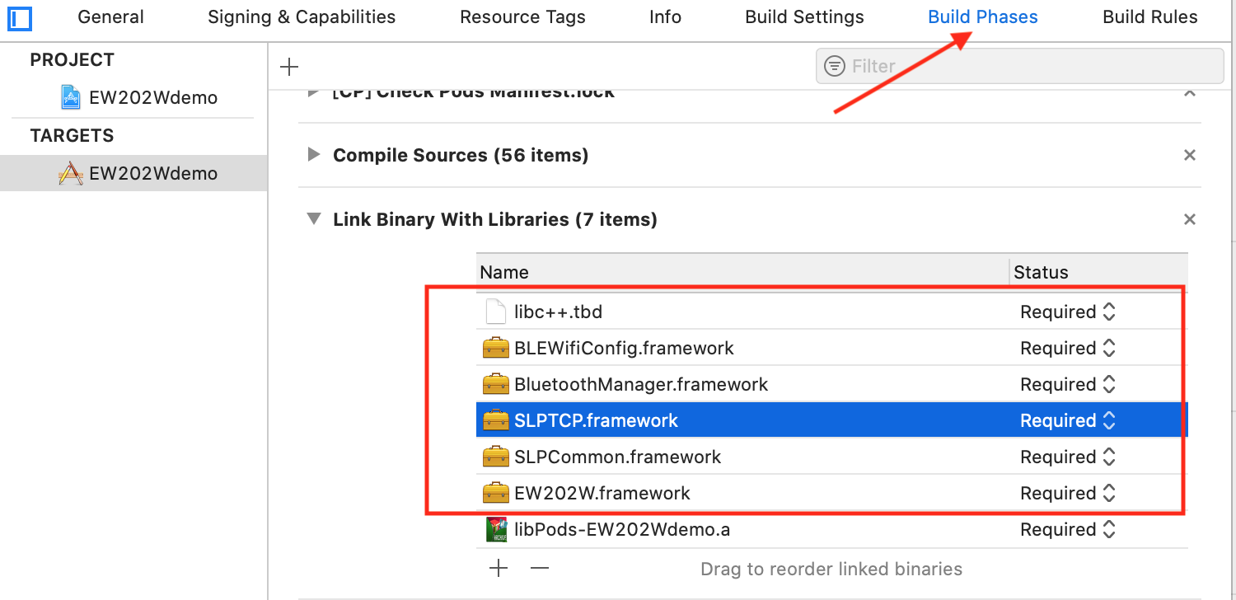

2: other linker flags add library link
-force_load $(SRCROOT)/ Swift_TWPSDKDemo /libs/SLPTCP.framework/SLPTCP
Attentions：The library relative address is behind $(SRCROOT)
If use CocoaPods to manage AFNetworking, need to add $(inherited)
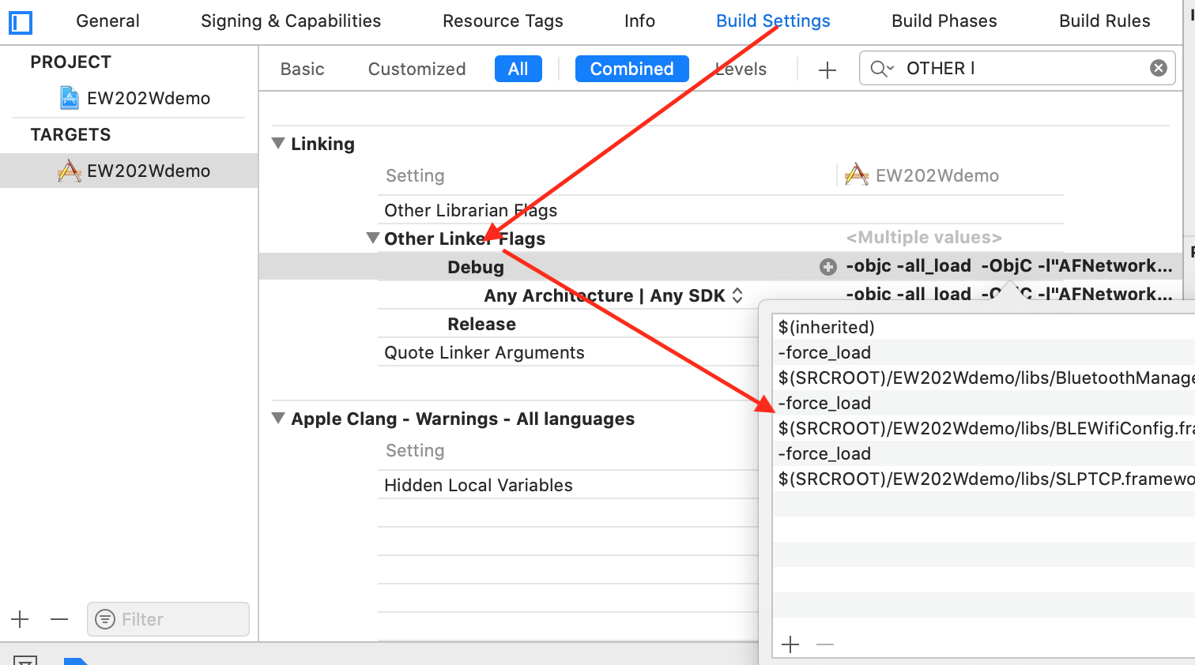

III. API Description

How to Call API
You need to call the HTTP interface to get the authorized TCP address and the port number before using the TCP API. See details in Common.framework document description.

- Device Operation
#import <SLPTCP/SLPTCP.h>
[SLPSharedLTcpManager <方法>]

TCP Connect and Disconnect
SLPLTcpManager manage the connection and disconnection of TCP.

Connect and login the TCP Interface
- (BOOL)loginHost:(NSString *)host port:(NSInteger)port deviceID:(NSString *)deviceID token:(NSString *)token completion:(void(^)(BOOL succeed))completion

Parameter Description
Field | Type | Description
host | NSString | TCP connect IP
port | NSInteger | Port
deviceID | NSString | Device ID
Token | NSString | token
completion |  | Block call back

Disconnect TCP Interface Automatically
- (void)disconnectTCPCompletion:(void(^)(void))completion

TCP Disconnect Call Back Delegate
- (void)tcpDidDisconnect:(SLPLTcp *)tcp

Description：TCP disconnect call back SLPTCPManagerDelegate interface function

TCP connection change notification：
@NSNotificationName kNotificationNameLTCPDisconnected TCP disconnected notification
@NSNotificationName kNotificationNameLTCPConnected TCP connected notification

Turn on Real-time Data
- (void)startRealTimeDataWithDeviceID:(NSString *)deviceID deviceType:(SLPDeviceTypes)deviceType timeout:(CGFloat)timeout callback:(SLPTransforCallback)handle;

Interface Description
TCP start to turn on device real-time data interface

Parameters Description
Field | Type | Description
deviceID | NSString | Device ID
deviceType | Int | Device type
timeout | Float | Time-out period
handle | SLPTransforCallback | Call back

Stop Real Time Data
- (void)stopRealTimeDataWithDeviceID:(NSString *)deviceID deviceType:(SLPDeviceTypes)deviceType timeout:(CGFloat)timeout callback:(SLPTransforCallback)handle;

Interface Description
TCP stop real-time data interface

Parameters Description
Field | Type | Description
deviceID | NSString | Device ID
deviceType | Int | Device type
timeout | Float | Time-out period
handle | SLPTransforCallback | Call back

3. Device Start to Collect (abandoned)
- (void)startCollectionWithDeviceID:(NSString *)deviceID deviceType:(SLPDeviceTypes)deviceType userID:(NSString *)userID timeStamp:(UInt32)timeStamp timeout:(CGFloat)timeout callback:(SLPTransforCallback)handle;

Interface Description
Start to collect interface

Parameters Description
Field | Type | Description
deviceID | NSString | Device ID
deviceType | Int | Device type
userID | NSString | User ID
timestamp | Uint32 | Start to collect time (time stamp)
timeout | Float | Time-out period
handle | SLPTransforCallback | Call back

4. Device Stop to Collect
- (void)stopCollectionWithDeviceID:(NSString *)deviceID deviceType:(SLPDeviceTypes)deviceType userID:(NSString *)userID timeStamp:(UInt32)timeStamp timeout:(CGFloat)timeout callback:(SLPTransforCallback)handle;

Interface Description
Stop to collect interface

Parameters Description
Field | Type | Description
deviceID | NSString | Device ID
deviceType | Int | Device type
userID | NSString | User ID
timestamp | Uint32 | Stop to collect time (time stamp)
timeout | Float | Time-out period
handle | SLPTransforCallback | Call back

5.Get Collection Status
- (void)getCollectionStatusWithDeviceID:(NSString *)deviceID deviceType:(SLPDeviceTypes)deviceType timeout:(CGFloat)timeout callback:(SLPTransforCallback)handle;

Interface Description
Get Device Collection Status

Parameters Description
Field | Type | Description
deviceID | NSString | Device ID
deviceType | Int | Device type
timeout | Float | Time-out period
handle | SLPTransforCallback | Call back

6. Get Sleep Status
- (void)getSleepStatusWithDeviceID:(NSString *)deviceID deviceType:(SLPDeviceTypes)deviceType timeout:(CGFloat)timeout callback:(SLPTransforCallback)handle;

Interface Description
Get sleep status

Parameters Description
Field | Type | Description
deviceID | NSString | Device ID
deviceType | Int | Device type
timeout | Float | Time-out period
handle | SLPTransforCallback | Call back

7. Get Environment Parameters
- (void)getEnvironmentInfoWithDeviceID:(NSString *)deviceID timeout:(CGFloat)timeout callback:(SLPTransforCallback)handle;

Interface Description
Query environmental parameters: temperature and humidity

Parameters Description
Field | Type | Description
deviceID | NSString | Device ID
timeout | Float | Time-out period
handle | SLPTransforCallback | Call back

8.Firmware Upgrade Notification
- (void)publicUpdateOperationWithDeviceID:(NSString *)deviceID deviceType:(SLPDeviceTypes)deviceType firmwareType:(UInt8)firmwareType firmwareVersion:(UInt16)version timeout:(CGFloat)timeout
callback:(SLPTransforCallback)handle;

Interface Description
Device upgrade function

Parameters Description
Field | Type | Description
deviceID | NSString | Device ID
deviceType | Int | Device type
firmwareType | Int | Upgrade type
version |  | Firmware upgrade version
timeout | Float | Time-out period
handle | SLPTransforCallback | Call back

9.Query the Device WiFi Signal(firmware>1.37)
- (void)publicGetWiFiSignalWithDeviceID:(NSString *)deviceID deviceType:(SLPDeviceTypes)deviceType timeout:(CGFloat)timeout callback:(SLPTransforCallback)handle;

Interface Description

Query the wifi signal of equipment

Parameters Description
Field | Type | Description
deviceID | NSString | Device ID
deviceType | Int | Device type
timeout | Float | Time-out period
handle | SLPTransforCallback | Call back ,back SLPTCPWiFiInfo object

10.Query the Device Online Status
- (void)publicGetOnlineStatusWithDeviceID:(NSString *)deviceID deviceType:(SLPDeviceTypes)deviceType timeout:(CGFloat)timeout callback:(SLPTransforCallback)handle;

Interface Description

Query the online status of equipment

Parameters Description
Field | Type | Description
deviceID | NSString | Device ID
deviceType | Int | Device type
timeout | Float | Time-out period
handle | SLPTransforCallback | Call back

IV. Object Description

Notification

Description
Object: TCP handle of the device SLPLTcp*lTcp
UserInfo: @{key: Content }

Description
Key | Content | Description
kNotificationNameTCPDeviceUpdateRateChanged | SLPLTcpUpgradeInfo | Upgrade Progress
kNotificationNameLTCPDisconnected |  | tcp connection: disconnected
kNotificationNameLTCPConnected |  | tcp connection: connected
kNotificationNameRequestDeviceOnlineStatusChanged |  | Device online status changed
kNotificationNameWiFiDeviceRealtimeData |  | Post real-time data
kNotificationNameDeviceSleepStatusChanged |  | Sleep status changed
kNotificationNameDeviceCollectStatusChanged |  | Device collection status changed
kNotificationNameHistoryDataUploadFinished |  | Historical data upload finished
kNotificationNameRequestDeviceWiFiSignalChanged |  | Wifi signal changed

SLPBLEScanReturnCodes

Description
Fileds | Value | Description
SLPBLEScanReturnCode_Normal | 0 | Successfully scanned a Bluetooth device
SLPBLEScanReturnCode_Disable | 1 | Bluetooth is disable
SLPBLEScanReturnCode_TimeOut | 2 | Scan Timeout

SLPDeviceTypes

Description
Fileds | Value | Description
SLPDeviceType_M800 | 0x26 | M800 device type

SLPTransforCallback

Description
Callback on Bluetooth or TCP requests

Method Statement
typedef void(^SLPTransforCallback)(SLPDataTransferStatus status,id data);

Parameter Description
Field | Type | Description
status | SLPDataTransferStatus | TCP or Bluetooth request callback data, see SLPDataTransferStatus for details
data | id | The callback data is valid when the status is SLPDataTransferReturnStatus_Succeed. User must convert to a corresponding object with a different interface. For details, please see each Interface Description.

SLPDataTransferStatus

Description
Fields | Value | Description
SLPDataTransferStatus_Succeed | 0 | Succeed
SLPDataTransferStatus_ConnectionDisconnected | 1 | Disconnected
SLPDataTransferStatus_TimeOut | 2 | Time out
SLPDataTransferStatus_Failed | 3 | Failed
SLPDataTransferStatus_ConnectionDisabled | 4 | Connection disabled or WIFI Disconnected
SLPDataTransferStatus_ParameterError | 5 | Parameter error

SLPPeripheralInfo

Description
Bluetooth scan call back

Fields Description
Fields | Value | Description
peripheral | CBPeripheral | Bluetooth handle
name | String | Device name

SLPDeviceInfo

Description
Device connection interface will call back

Fields Description
Field | Type | Description
deviceID | String | Device ID
version | String | Firmware upgrade version

SLPEnvironmentInfo

Description
Interface that get the temperature and humidity will call back

Fields Description
Field | Type | Description
errorCode | Int | See SLPTCPBaseEntity: errorcode
Temperature | Int | Temperature: -127~127
humidity | Int | Humidity: 0~100

SLPCollectStatus

Description
Device collection status

Fields Description
Field | Type | Description
errorCode | Int | See SLPTCPBaseEntity: errorcode
deviceID | NSString | Device ID
deviceType | UInt16 | Device type
CollectionStatus | UInt8 | Collection status value  1: collecting  2: not collecting
Starttime | UInt32 | start time (time stamp)
isCollecting | BOOL | whether is collecting or not

SLPLTcpUpgradeInfo

Description
After the firmware upgrade interface is called, the device will report upgrade status automatically, monitor notification kNotificationNameTCPDeviceUpdateRateChanged can acquire.

Fields Description
Field | Type | Description
rate | NSInteger | Upgrade process（0-100%）

SLPSleepStatus

Description
Device sleep status value

Fields Description
Field | Type | Description
errorCode | Int | See SLPTCPBaseEntity: errorcode
deviceID | NSString | Device ID
deviceType | UInt16 | Device type
sleepFlag | UInt8 | Asleep or not  0x00: not  0x01: asleep  others: invalid
weakFlag | UInt8 | Awake or not  0x00: not  0x01: awake  others: invalid
LeftbedFlag | UInt8 | Leave bed or not  0x00: not  0x01: leave bed  others: invalid
sleepStatus | UInt8 | 睡眠深度  0x00: 无效（表示暂不支持该功能）  0x01: 清醒  0x02: 浅睡  0x03: 中睡  0x04: 深睡
sitStatus | UInt8 | Sit status  0x00: lying down  0x01: sitting up

SLPTCPPostRealtimeData

Description
Post real time data

Fields Description
Field | Type | Description
deviceID | NSString | Device ID
deviceType | NSInteger | Device type
dataNumber | UInt8 | Data number
dataList | NSArray< SLPRealtimeDataBase *> | Real time data list

SLPRealtimeDataBase

Description
Real time data point

Fields Description
Field | Type | Description
br | Uint8 | Respiratory rate
hr | Uint8 | Heart rate
brStatus | NSInteger | status  0x00：normal；0x01：initiation；0x02 apnea；0x03：heart beat pause；0x04(invalid)：body movement；0x05：leave bed；0x06：turn over；0x07：amplitude of body movement；-1：invalid
isOffBed | BOOL | Leave bed or not
isInit | BOOL | Initiation or not
timestamp | NSIteger | Time stamp
sleepFlag | NSIteger | Asleep or not 0: not 1: asleep
awakeFlag | NSIteger | Awake or not 0: not 1: awake
temperture | NSIteger | Temperature
humidity | NSIteger | Humidity

SLPTCPOnlineStatus

Description
Online status

Fields Description
Field | Type | Description
deviceID | NSString | Device ID
deviceType | UInt16 | Device type
onlineStatus | onlineStatus | Online status
isOnline | BOOL | Online or not
errorCode | Int | See SLPTCPBaseEntity: errorcode

SLPTCPBaseEntity

Description
TCP interface call back fundamental class, status code show reason when fails

Fields Description
Field | Type | Description
errorCode | Int | 0x00, // succeed  0x01,//sever error  0x02,//log out  0x04,//Reston not binded  0x05,//Reston is binded  0x07,//app offline  0x08,//Reston offline  0x09,//Request data does not exist  0x0a,//Insufficient permissions  0x0b,//Operation failed  0x0c,//Failed to find Reston  0x0d,//Failed to connect Reston  0x0f,//upgrading  0xff,//unknown error

